**How to analyze log domain communication my2.0**

**Kibana**

**[prod]** <https://prd-kibana-next.adldigitalservice.com/s/mfaf-jpe-prd/app/home#/>

**[stg]** <https://stg-kibana-next.adldigitalservice.com/s/mfaf-jpe-stg/app/home#/>

**Goto Discover App & select index ‘DOS-Detail’**

1. **Analyze pushindividual ( push notification from BIM & NGCM)**
   1. filter by componentName: "common.communication" and instance:"pushindividual"

and message:"089xxxxxxx"  
( msisdn support for local & inter format )

* 1. action=[CONSUMING] message is request message

* 1. action=[APP LOGIC] message is result of asset find myId

*keep correlationId for check DB_RESPONSE & HTTP_REQUEST

* 1. action=[DB_RESPONSE] message is response from insert DB

* 1. action [HTTP_REQUEST] is request to push notification to PNS (legacy)

1.6 action [HTTP_RESPONSE] is response from PNS

use sesstionId for tracking response from PNS

** response characteristic.name: "pushRefId" {xxxx-xxxx-xxxx-xxxx-xxxx} -> success

1. **Analyze readstate ( read message from my2.0 )**
   1. filter by componentName: "common.communication" and instance:"readstate"

and public:"089xxxxxxx"

* 1. action=[CONSUMING] is request update read from ODA
  2. action=[PRODUSING] is response update status to ODA

1. **Analyze deletestate ( delete message from my2.0 )**
   1. filter by componentName: "common.communication" and instance:"deletestate"

and public:"089xxxxxxx"

* 1. action=[CONSUMING] is request update delete from ODA
  2. action=[PRODUSING] is response update status to ODA

1. **Analyze subscribe**

update deviceToken to PNS and create serviceInventoryNotification if not exist

source topics

mfaf.myIdAnonymousOnboarded

mfaf.myIdDeviceRegistered

mfaf.myIdDeviceLoggedIn

mfaf.myIdDeviceLoggedOut

* 1. filter by componentName: "common.communication" and instance:"subscribe" and public:"0934000839"

*keep **sessionId for tracking**

* 1. consuming source topics and focus TORO_deviceInfo.isCurrent : true

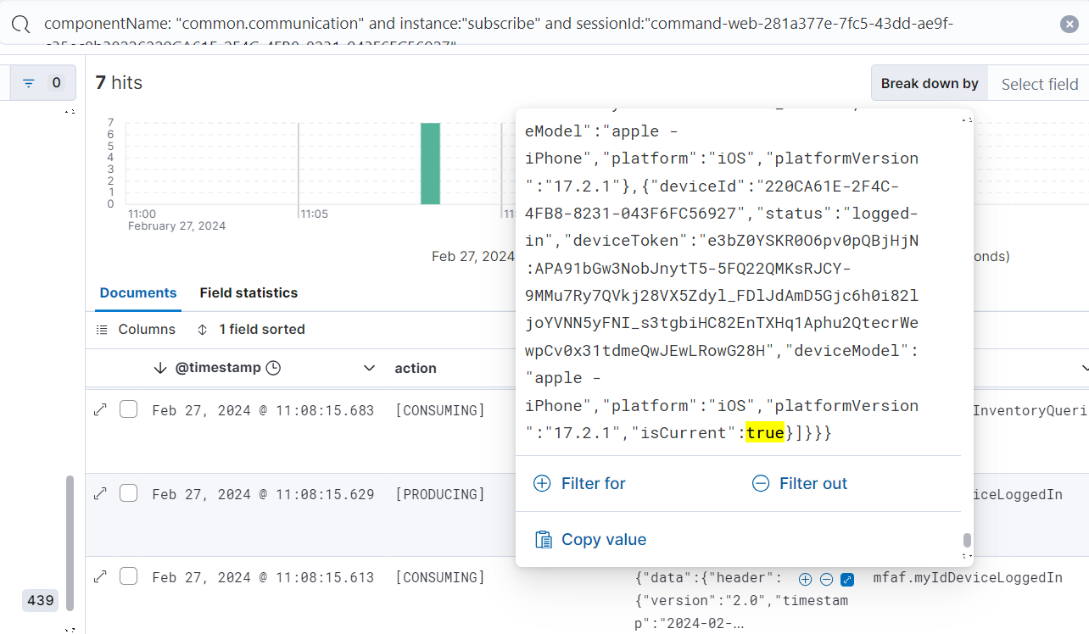

*keep identiry.user ( myId ) for queryProductInventory

* 1. query ProductInventoryby identity.user (myId)

**producing topic mfaf.queryProductInventory**

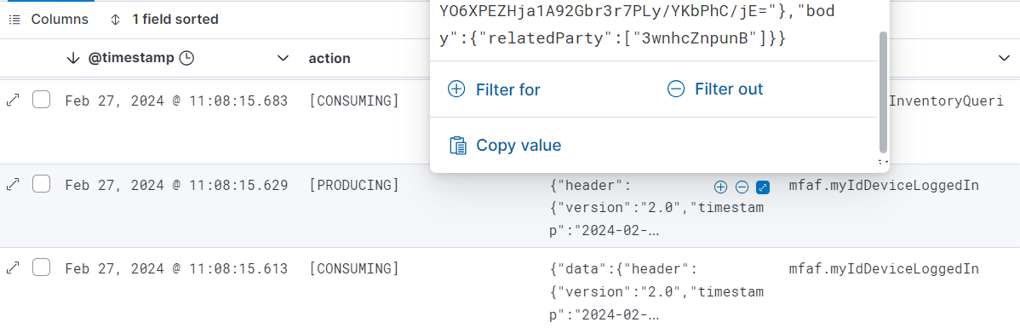

*if not found from productInventory

Subscribe will produce to **mfaf.createServiceInventoryNotification**

* 1. consuming result **mfaf.productInventoryQueried** & keep id of realizingService.name : "Notification" (last object)

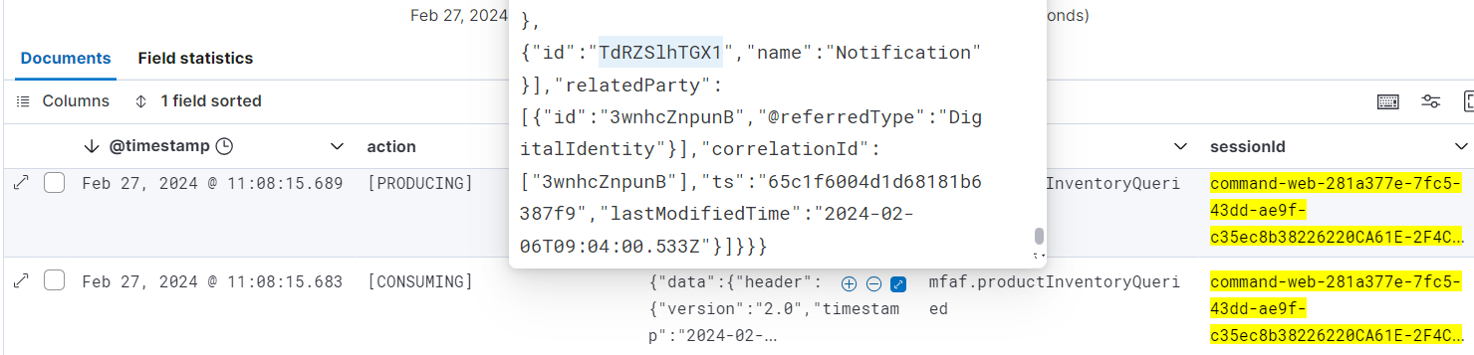

* 1. query serviceInventory by id realizingService.name: "Notification"

product topic mfaf.inquiryServiceInventory

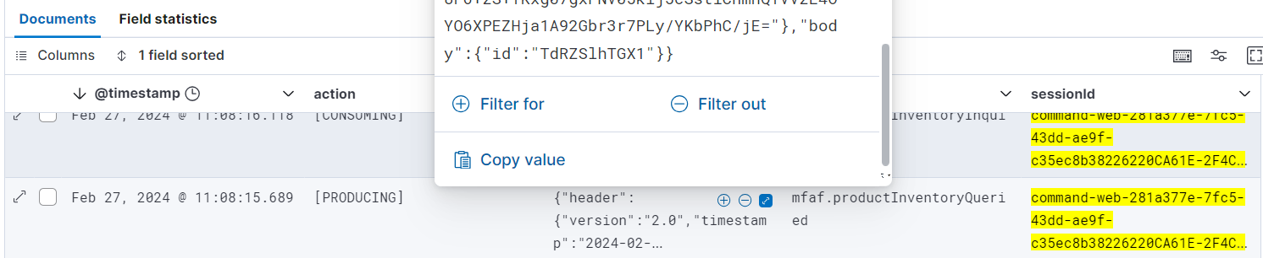

*if not found from serviceInventory

Subscribe will produce to **mfaf.createServiceInventoryNotification**

* 1. consumingresult **mfaf.serviceInventoryInquired**

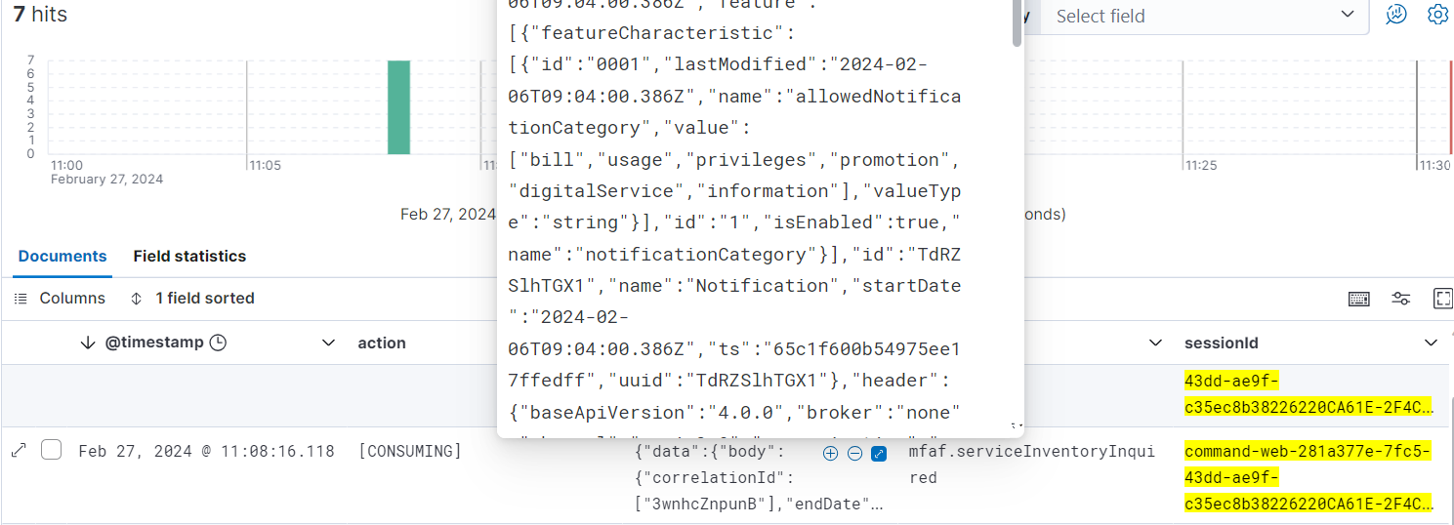

* 1. http_request update deviceToken to PNS

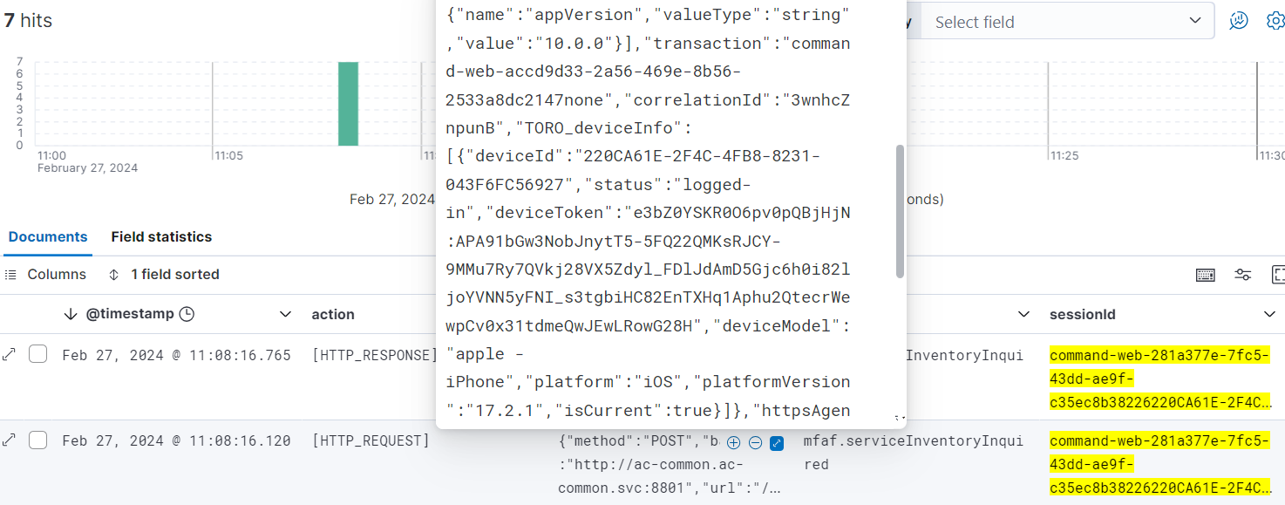

* 1. http_response from PNS

